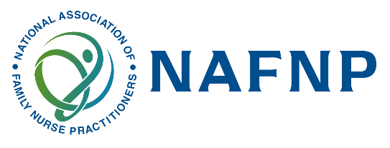
National Association of Family Nurse Practitioners Virtual Poster Presentation-2025
The National Association of Family Nurse Practitioners (NAFNP) invites submissions for its upcoming Virtual Poster Presentation! This exciting event offers a platform to showcase innovative ideas, research, and quality improvement initiatives that advance nurse practitioner practice, education, and patient care.
We encourage submissions in the following areas:
- Research & Quality Improvement Projects: Groundbreaking studies, process enhancements, or evidence-based practice initiatives aimed at improving outcomes.
- Nurse Practitioner Education: Innovations in teaching methods, curriculum development, or strategies to enhance NP training.
- Simulation: Utilization of simulation in education, practice, or training to enhance clinical skills or improve patient safety.
- Clinical Practice: Best practices, case studies, or strategies that optimize patient care in clinical settings.
Student-Led Initiatives and Proposals are highly encouraged and welcomed! This is an excellent opportunity for emerging leaders to showcase their contributions and engage with a broader audience.

Submission Guidelines:
- Abstract Length: 250–300 words
- Format: Include a title, background, objectives, methods, results, and implications for practice (if applicable).
- Eligibility: Open to all nurse practitioners, students, educators, and researchers who are members of NAFNP.
- Deadline for Submission: March 15, 2025

Key Dates:
- Abstract Submission Opening: February 22, 2025
- Abstract Submission Deadline: March 15, 2025
- Notification of Acceptance: April 1, 2025
- Poster/Files Submission: May 10, 2025
- Virtual Poster Presentation Event: June 10, 2025

How to Submit:
Instructions for submission and the abstract submission form can be found on the Scholarship Committee page on NAFNP.org. For questions or more information, please email: scholarship@NAFNP.org. © National Association of Family Nurse Practitioners LLC 2025

